Project 1 Proposal / Conceptual References
Shader Programming and Procedural Modeling
Meshal Aljifry
Michael Tetzlaff
09/12/2024

Objective
I will create a parametric texture pack in Substance Designer and showcase it in Unreal Engine 5 using a simple lit scene. The texture pack will include five unique materials, each utilizing a PBR (Physically Based Rendering) material model. These materials will be designed with flexibility and customization in mind, using parameters adjustable within Unreal Engine 5. The materials will follow specific guidelines and feature grunge/wear effects where appropriate.
Materials Overview:
- Tiled Ceramic Tiles (Tile Generator)
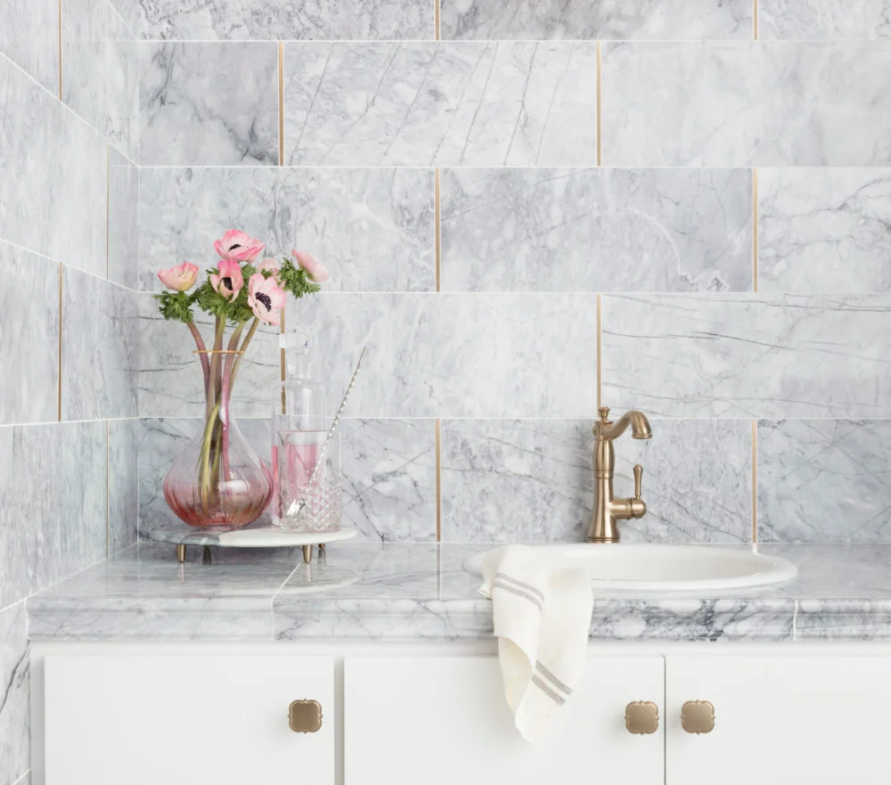
  - Real-World Reference:

  - Physical Information:
    - Albedo: Light to mid-tone colors, often white, beige, or light blue. Tiles are dielectric.
    - Wear/Damage: Grout discoloration, scratches on the glossy surface, and chipped edges.
  - Scientific Data: The polished surface reflects light, so careful roughness control will simulate different finishes.
  - Parameters: I will adjust tile size, grout width, surface roughness, and color variations.
  - Type: Dielectric, Tile Generator-based.
- Worn Metallic Panel (Metallic)
  - Real-World Reference:
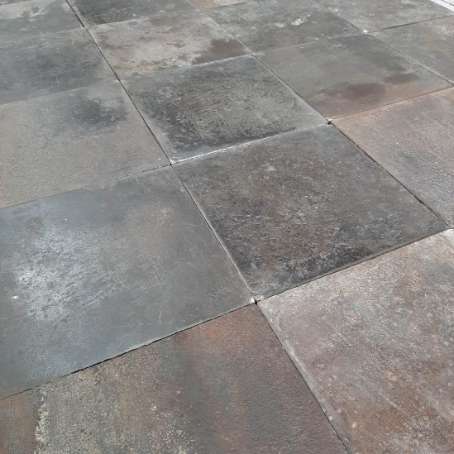

  - Physical Information:
    - Albedo: Reflective metal with darker areas due to oxidation or grime.
    - Wear/Damage: Visible scratches, dents, and potential rust patches or oil stains.
  - Scientific Data: High metallic values, with roughness varying depending on wear and weathering.
  - Parameters: Adjustable oxidation, wear intensity, and dirt layers.
  - Type: Metallic.
- Marble (Subsurface Scattering)
  - Real-World Reference:
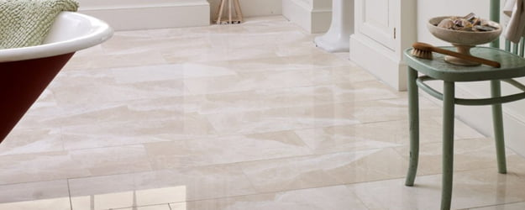
    - Photograph: Polished marble surface in a museum or luxury setting.

  - Physical Information:
    - Albedo: White, gray, or black with veining. Marble is dielectric.
    - Wear/Damage: Usually polished but may have subtle wear at the edges. No significant scratching.
  - Scientific Data: Subsurface scattering helps capture how light penetrates slightly into the material before diffusing.
  - Parameters: Control veining pattern, subsurface depth, and polish intensity.
  - Type: Subsurface scattering.
- Rusty Metal Fence
  - Real-World Reference:
Rusty iron fence with layers of corrosion.
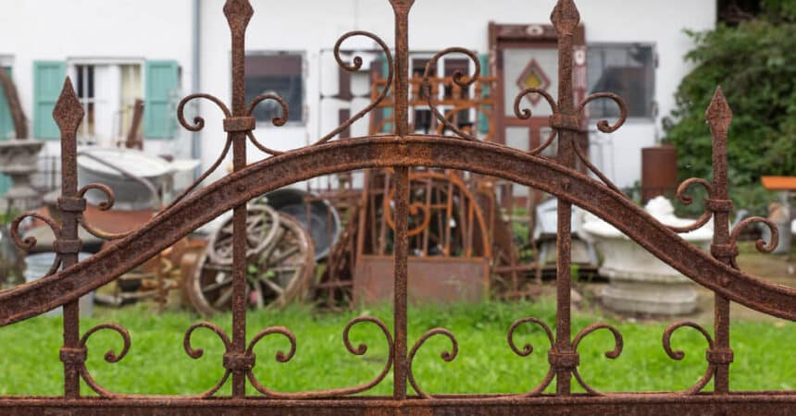
  - Physical Information:
    - Albedo: Deep oranges and browns with patches of dark rust. This is a metallic material.
    - Wear/Damage: Heavy corrosion with rust flakes and rough patches.
  - Scientific Data: High metallicity, but roughness should be highly varied due to corrosion.
  - Parameters: Adjustable rust intensity and placement.
  - Type: Metallic with significant weathering.
- Automotive Paint (Clearcoat)
  - Real-World Reference:
A close-up of a car with a glossy, clear-coated finish.
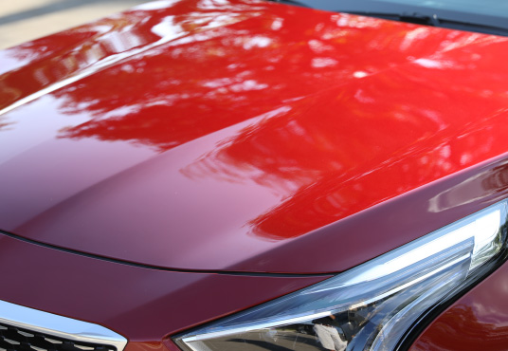

  - Physical Information:
    - Albedo: Bright, saturated colors like red or blue. This is a dielectric material with a clearcoat layer.
    - Wear/Damage: Subtle scratches in the clearcoat and paint chipping along the edges.
  - Scientific Data: Uses Unreal's clearcoat extension to simulate the layered structure.
  - Parameters: Control clearcoat thickness, polish, and level of wear.
  - Type: Clearcoat dielectric.
Grunge and Wear:
Each material will feature grunge, wear, or damage to some degree to enhance realism:
- Ceramic Tiles: Grout discoloration and edge chipping.
- Metallic Panel: Dents, scratches, and rust buildup.
- Marble: Slight edge wear or patina over time.
- Rusty Fence: Corrosion patterns and texture variations.
- Automotive Paint: Subtle scratches in the clearcoat and paint chipping.
Conclusion:
This texture pack will demonstrate my ability to craft a variety of materials that reflect both real-world wear and artistic customization. With the adjustable parameters, each material will provide flexibility within Unreal Engine 5, making them suitable for a wide range of environments.

